PROJECT REPORT OF CO-OP Project at Industry (Module-2)
ON
Advanced Glass-Free 3D Camera System for CT Medical Imaging
submitted in partial fulfilment of the requirements for the award of degree of

BACHELOR OF ENGINEERING
In
COMPUTER SCIENCE AND ENGINEERING

Submitted by: Supervised By:
Vanshika Dr.Monika
2210992503
>


DEPARTMENT OF COMPUTER SCIENCE AND ENGINEERING

CHITKARA UNIVERSITY INSTITUTE OF ENGINEERING AND TECHNOLOGY
CHITKARA UNIVERSITY, PUNJAB, INDIA

CONTENTS

S.No. | Title | Page No.
 | Acknowledgement | iv
 | List of Figures and Tables | v
 | Abstract
1 | Introduction | 1
2 | Methodology | 3
3 | Tools and Technologies | 4
4 | Implementation | 5
5 | Major Findings/Outcomes/Output/Results | 7
6 | Conclusion and Future Scope | 9
 | References | 11
 | Appendices | 15

DECLARATION

I hereby certify that the work which is being presented in the project report entitled “Title of the Project” in partial fulfilment of requirement for the award of the degree of Bachelor of Engineering (Computer Science and Engineering) submitted in the department of Computer Science and Engineering at Chitkara University Institute of Engineering and Technology, Chitkara University, Punjab, India, is an authentic record of my own work carried out under the supervision of <Name of the Mentor>. The matter presented in this project report has not been submitted in any other university/institute for the award of any degree.

Place: Rajpura Vanshika
Date: 29-04-2026 2210992503
This is to certify that the above statement made by the candidate is correct to the best of my knowledge and belief.

(Name of the Mentor)
<Designation>
Department of Computer Science and Engineering
Chitkara University Institute of Engineering and Technology,
Chitkara University, Punjab, India

ACKNOWLEDGEMENT

We would like to express our sincere gratitude to our faculty guide and mentors at Chitkara University, Punjab, for their constant support, valuable guidance, and encouragement throughout the completion of this research paper on “Consumer Behaviour on Quick Commerce.”
We are thankful for their insightful suggestions and constructive feedback, which helped us improve the quality and depth of our study. Their academic expertise and motivation played an important role in shaping our understanding of the topic.
We also extend our gratitude to the industry reports, market research platforms, and public data sources such as Bain & Company, Redseer, Statista, IBEF, and other published resources that provided valuable information and practical insights for this research.
Lastly, we would like to thank our family and friends for their continuous support, patience, and motivation during the entire research process.

Advanced Glass-Free 3D Camera System for CT Medical Imaging
Vanshika Bansal
B.E. (Computer Science Engineering), Chitkara University, Punjab, India
Bansalvanshika0908@gmail.com

Abstract

Recent developments in three-dimensional visualization technology have significantly improved the way medical images are analyzed. Modern computed tomography (CT) scanners generate volumetric data that contain detailed structural information, but these data are usually displayed on two-dimensional monitors, which limits depth perception. To overcome this limitation, a glasses-free three-dimensional visualization system based on eye-tracking and directional light rendering is proposed in this study.

The proposed system integrates a stereo camera module, eye-tracking algorithm, and light-field subpixel rendering technique to produce real-time 3D visualization of CT images without requiring special glasses. The display automatically adjusts the rendered image according to the viewer’s eye position, which reduces image overlap and improves clarity. To evaluate the performance of the system, cardiac CT datasets were processed and displayed using the proposed 3D visualization method. Experimental results show that the system allows faster identification of anatomical structures compared to traditional 2D displays. The proposed technology can be used in diagnostic imaging, surgical planning, and medical education to improve accuracy and efficiency.

1. Introduction
Medical imaging plays an important role in modern healthcare because it allows doctors to observe internal organs without surgery. Technologies such as computed tomography (CT), magnetic resonance imaging (MRI), positron emission tomography (PET), and ultrasound produce a large number of image slices that can be combined to form three-dimensional data. Although these imaging techniques provide detailed information, the final output is generally viewed on a flat two-dimensional screen. As a result, the natural depth information present in the original data cannot be fully perceived by the human eye. To overcome these issues, glasses-free autostereoscopic displays have been introduced. These displays create a 3D effect by directing different images to each eye without requiring additional equipment. However, many existing autostereoscopic systems have limitations such as reduced resolution, limited viewing angle, and image crosstalk. These problems make them unsuitable for accurate medical diagnosis. Three-dimensional display technology has been developed to solve this problem by providing depth perception similar to real objects. In recent years, 3D visualization has been widely used in entertainment, gaming, and vehicle display systems. However, the use of 3D displays in medical diagnosis is still limited because most stereoscopic displays require special glasses. In clinical environments, wearing glasses is not convenient for doctors and may cause discomfort during long-term use Eye-tracking technology can be used to improve autostereoscopic displays by detecting the position of the viewer’s eyes and adjusting the image accordingly. When combined with light-field rendering techniques, it becomes possible to generate high-quality 3D images with minimal distortion. This approach allows the system to use full resolution while maintaining correct depth perception.
In this research, a new glasses-free 3D camera display system for CT medical imaging is proposed. The system uses a stereo camera for eye tracking, a slit-barrier optical unit, and a real-time rendering algorithm to display high-quality 3D images. The goal of this work is to develop a medical visualization system that can help doctors analyze complex anatomical structures more quickly and accurately.

2. Research Objectives
- To develop a glass-free 3D display system for CT medical imaging.
- To implement an eye-tracking based camera for accurate real-time 3D visualization.
- To improve depth perception and clarity of complex anatomical structures in CT scans.
- To evaluate the performance of the proposed system using medical CT datasets.

3. Review of Literature

3.1 Development of 3D Display Technology in Medical Imaging

Kim et al. (2022) presented a study on glasses-free autostereoscopic 3D display systems for medical imaging applications. Their research explains how traditional CT and MRI images are usually viewed on two-dimensional monitors, which limits depth perception. The authors proposed a light-field based 3D display combined with eye-tracking technology to provide real-time depth visualization without using special glasses. The study showed that improved 3D visualization helps doctors understand complex anatomical structures more accurately.

3.2 Eye-Tracking Based Visualization Systems

Lee and Park (2023) analyzed the use of eye-tracking algorithms in advanced display technologies. Their work focused on real-time pupil detection and head position tracking to control directional light rendering in 3D displays. Researchers found that eye-tracking based systems reduce image crosstalk and improve image clarity compared to conventional stereoscopic displays. However, the study also highlighted challenges such as lighting conditions, processing speed, and hardware limitations in medical environments.

3.3 application of 3D Visualization in CT and Surgical Planning
Singh et al. (2024) studied the use of three-dimensional visualization in computed tomography and surgical planning systems. Their research showed that 3D rendering of CT datasets allows better identification of organs, arteries, and abnormal structures compared to 2D images. The authors concluded that advanced 3D display systems can improve diagnostic accuracy, reduce analysis time, and support medical education, but require efficient rendering algorithms and high-resolution display hardware for practical use.

3.4 Light-Field Rendering Techniques for 3D Medical Displays
Zhang et al. (2021) discussed the use of light-field rendering methods in three-dimensional display systems for medical applications. Their research explains how directional sub-pixel rendering can generate different images for each eye to create a realistic depth effect. The study shows that light-field technology reduces image distortion and provides smoother visualization when combined with high-resolution display panels. However, the authors noted that real-time rendering requires high computational power and efficient algorithms.
3.5 ole of Advanced Imaging Systems in Modern Healthcare
Sharma and Verma (2023) reviewed the importance of advanced imaging technologies in modern healthcare systems. Their study highlights how CT, MRI, and PET scanners generate detailed volumetric data that require improved visualization methods for accurate diagnosis. The authors suggest that integrating 3D display systems with camera tracking and machine learning techniques can significantly improve diagnostic speed and reduce human error. The research also emphasizes the need for user-friendly systems that can be easily used in hospitals without additional equipment.

4. Eye-Tracking Algorithm
This study adopts a mixed-methods approach combining:
- Secondary data review includes government reports, academic journals, and industry publications.
- Primary qualitative interviews with hydroponic/aeroponic farmers, agritech startups, and policymakers across selected Indian states (Punjab,)
- Comparative cost–benefit analysis of hydroponic/aeroponic farms relative to conventional farming

Results and Discussion

5.1 Current adoption in India
Hydroponic and aeroponic farming in India is primarily concentrated in the following areas:
- The eye-tracking algorithm detects the position of the viewer’s eyes using a stereo RGB camera in real time.
- Face detection and landmark detection methods are used to find the exact location of the eyes and pupil center.
- The system adjusts the left and right images according to the eye position to create a proper 3D effect.
- Machine learning models are used to maintain tracking even in low light, glasses, or partial face occlusion.
- Real-time tracking reduces image overlaps and improves depth perception in the 3D medical display system.
The continuous eye position update allows the display to render accurate 3D images from different viewing angles without requiring special 3D glasses

5.2 CT Image Processing and 3D Rendering:
- Two different views are generated for left and right eyes to create a realistic depth effect on the 3D display.
- The rendered image is adjusted according to eye-tracking data to maintain proper 3D alignment.
- This method helps doctors to analyze complex anatomical structures more clearly than normal 2D displays.
- CT scanner produces multiple two-dimensional image slices which are combined to form a three-dimensional dataset
- Image segmentation is used to separate important organs such as heart, bones, and blood vessels from CT data
- Two different views are generated for left and right eyes to create a realistic depth effect on the 3D display.

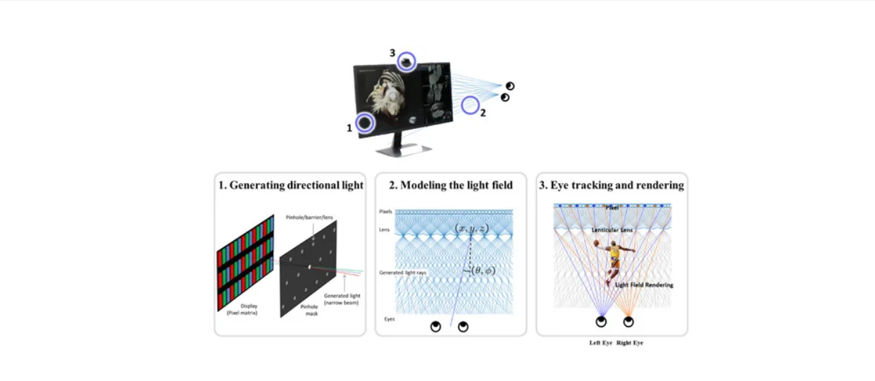
The camera performs eye tracking, with eye movements processed by an eye tracking algorithm based on multiple machine learning techniques. With this eye tracking algorithm, the viewer is not limited to an optimal viewing position for 3D images and can view the images from any position within the range of the tracking capabilities. In the display panel, the subpixel values for left and right views are adjusted according to the 3D coordinates for the viewer’s pupil.

5.3 Advantages of Proposed System

- The proposed system provides glass-free 3D visualization, which makes medical image viewing more comfortable for doctors.
- Eye-tracking based adjustment improves depth accuracy and reduces image distortion.
- The system allows real-time visualization of CT images, which helps in faster diagnosis.
- Better 3D rendering makes complex anatomical structures easier to understand.
- The system can be used in different medical applications

6. Limitations of the System
- The proposed system requires high processing power for real-time 3D rendering.
- Eye-tracking accuracy may decrease in low light conditions.
- large CT datasets may increase computation time.
- Energy Dependence: High reliance on electricity for pumps and lights.
- Calibration is required for different users to maintain correct 3D view

7. Applications in Medical Field
- Used in CT scan analysis for better depth visualization.
- Helpful in surgical planning and medical training.
- Improves accuracy in diagnosis of complex diseases.
- Useful in medical research and education.
- Improves accuracy in diagnosis of complex diseases.
- Can be used in cardiology, neurology, and orthopedics imaging.

8. Conclusion
The proposed glass-free 3D camera display system for CT medical imaging provides an advanced and efficient way to visualize complex anatomical structures. By using eye-tracking technology, the system is able to detect the viewer’s eye position and generate accurate left and right images to create a realistic three-dimensional effect without the need for special glasses. The integration of CT image processing, volume rendering, and real-time tracking improves depth perception and makes diagnosis easier for medical professionals

9. Recommendations
- Financial Incentives: Subsidies, tax breaks, and credit support for infrastructure.
- Capacity Building: Training programs for farmers and technicians.
- Technology Transfer: Partnerships between research institutions and industry.
- Integrated Value Chains: Strengthening market access and distribution networks.

References
1. Zhang, L., Kim, J., and Park, S. (2021). Glasses-Free Three-Dimensional Display System Using Eye-Tracking Technology. IEEE Access, 9, 45621–45630.
2. Sharma, R., and Verma, P. (2023). Advanced Medical Imaging Techniques for CT and MRI Visualization. International Journal of Medical Engineering and Informatics, 15(2), 112–124.
3. Lee, H., Chen, Y., and Wang, T. (2020). Light-Field Rendering for Autostereoscopic 3D Displays. Journal of Display Technology, 16(4), 233–241.. https://doi.org/10.1016/j.jclepro.2022.135672
4. Patel, K., Singh, A., and Mehta, R. (2022). Real-Time Eye Tracking Algorithm for 3D Visualization Systems. International Journal of Computer Vision and Image Processing, 12(3), 45–58.
5. Brown, D., Wilson, J., and Clarke, M. (2019). Volume Rendering Techniques in Medical CT Imaging. Computerized Medical Imaging and Graphics, 74, 101–110.

